*A lab is performed in which a string is vibrated at various frequencies and the corresponding wavelengths are measured. The data is shown in the table below. Plot the points on a graph.*

|  |  |
| --- | --- |
| Frequency | Wavelength |
| 50 Hz | 0.020 m |
| 40 Hz | 0.025 m |
| 30 Hz | 0.033 m |
| 20 Hz | 0.050 m |
| 10 Hz | 0.100 m |

1. Discuss the proporionality between the wavelength and the frequency.
2. When the frequency is doubled, what happens to the wavelength?
3. A 6-meter string is secured at both ends. When vibrated at just the right frequency it creates the standing wave seen in the diagram below. What is its wavelength?

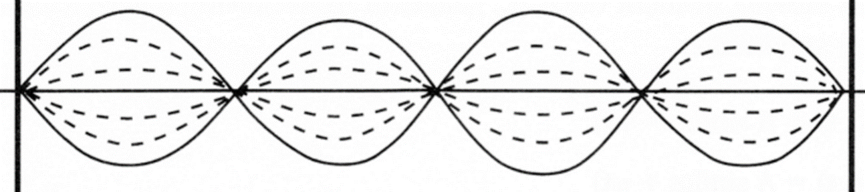

1. Is the picture above a transverse or longitudinal wave? How can you tell?
2. If a wave is traveling at 60 cm/second and has a wavelength of 15 cm, what is the frequency?
3. How can you change the speed at which a wave travels?